ABINGDON ARCHAEOLOGICAL GEOPHYSICS
4 Sutton Close, Abingdon, Oxon OX14 1ER
tel. 01235 529720 website www.archaeologicalgeophysics.co.uk
email: archgeophys@hotmail.co.uk

Chipping Norton Castle, Oxfordshire.

Report no. 2018-03
© Abingdon Archaeological Geophysics 2018

The report also contains a CD which has the data and illustrations to enable them to be archived and used in other publications and presentations.

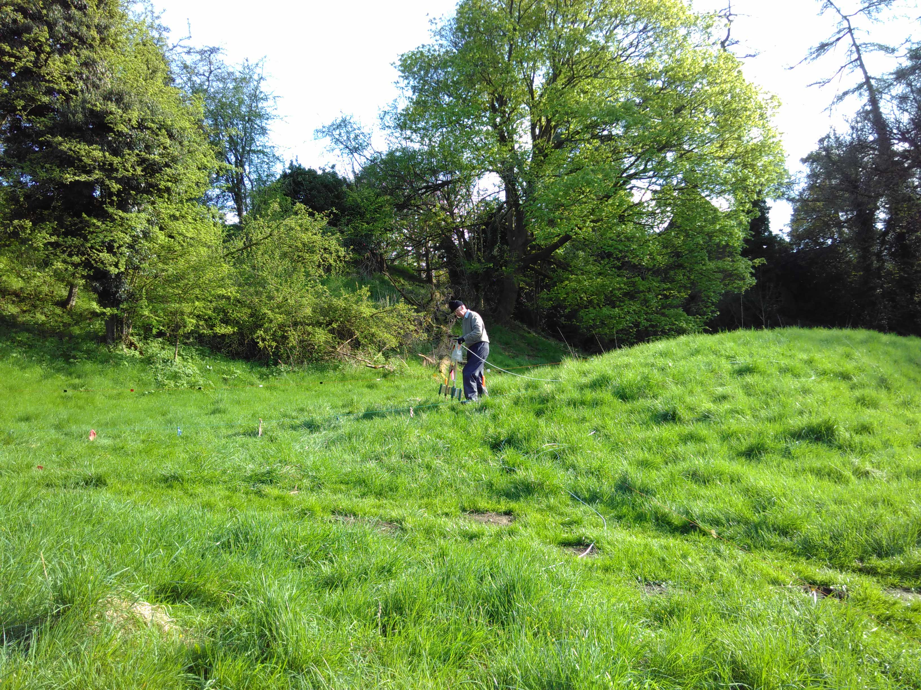

Author R Ainslie, Abingdon Archaeological Geophysics
Client The Chipping Norton Buildings Trust
Report reference no 2018 03v5
Date 1 July 2018

Contents

Summary 3

1 Survey details 3

2 Technical details 4

3 Results 4

4 Conclusions 5

5 Appendix1 Technical details of methods and equipment 17

CD with original data and digital copies of text and figures

List of figures

Fig 1: Earth resistance located on Google Earth air photo 7

Fig 2: Grid order and location detail 7

Fig 3 Clipped 15-87 ohms. Colour 8

Fig 4 Clipped 15-87 ohms. 9

Fig 5 Clipped 18-23 ohms. 10

Fig 6 Clipped 8-55 ohms. 11

Fig 7 Clipped 8-69 ohms. 12

Fig 8 Clipped 13-41ohms. 13

Fig 9 Trace plot 14

Fig 10 Plot on hachure map. 15

Fig 11 Interpretation 16

Summary

An earth resistance survey was carried out to investigate this area following an earlier magnetometry survey.
The earth resistance results were more reflective of the earthwork survey which had been carried out by students on a course tutored by English Heritage staff. Walls, several possible buildings and a circular feature were found.
The levels of resistance readings varied between the southern area, the northern one and the areas outside those areas. The wide range of readings may make it necessary to consider each area separately to prevent details being lost in the range of reading strengths.
Specialists in castle design may be able to identify many of the structures although the amount of parallel and double walls appears to be unusual to the non-expert.
The CD which accompanies the clients’ copy of this report also contains illustrations of the data processed in a range of ways.

1 Survey Details

Name of site: Chipping Norton Castle.

Purpose of survey:
An earth resistance survey was carried out to see if this could clarify earlier work and assist the clients researches into this area.

Client: The Chipping Norton Buildings Record
County: Oxfordshire District: West Oxfordshire Parish: Chipping Norton

NGR grid reference: Area approximately centred on SP312144
Nearest postcode: OX7 5NS
Start date: 13-04-2018 End date: 26-04-2018 Report date: This version 01-07-2018

Geology at site The geology is understood from the Geology of Britain viewer to be Whitby mudstone and Middle Lias (Dyram formation)

Topography: This is on a small hill, the sides separating it from the town may have been enhanced as part of the castle construction.

Field Conditions.
The field had grass with trees on slopes and patches of nettles which were about 20 cms high. Steep slopes prevented surveying in some areas and overhanging trees meant that other areas could not be surveyed, although this was less of a problem for resistivity than it had been for magnetometry. There had been rain before the survey and showers during the survey period. This may have affected the results as features such as hard surfaces can pond up groundwater and appear to be damp in wet conditions only to become high resistance dry features in drier conditions. As we needed to survey near the edges of the site to detect any wall at its edge and as those areas had most nettles and brambles, it was considered that the survey should take place before the vegetation prevented work, even though slightly drier conditions could have produced results with more contrast.

Known archaeological sites / monuments covered by the survey
The clients are understood to be researching this.
The site is a Scheduled Ancient Monument as being a motte and bailey castle with fishponds to the south west. A section 42 licence had been obtained to permit the survey.

Archaeological sites / monument types detected by the survey
We located several probably stone buildings, a circular pond - like feature and other walls and undiagnostic piles of rubble. Geophysics alone cannot give a date to remains.

Surveyor : Abingdon Archaeological Geophysics, Roger Ainslie, Sally Ainslie.

Location of:
a) Primary archive, i.e. raw data, electronic archive etc
Abingdon Archaeological Geophysics and with the client.
b) Full report: Ditto - also as part of the section 42 licence Historic England are to be provided with copies of the report.

2 Technical Details

Type of survey
Earth Resistance
Area surveyed: 1.1 hectares
Traverse separation, if regular: 0.5 metre.
Reading / sample interval: 0.5 metre
Type, make and model of instrumentation: TR Systems meter Mark 2.
Array: Twin probe. 0.5m mobile probe spacing.

Processing
We have used TerraSurveyor for this.
Data was processed to replace erroneous readings - usually caused by hitting stones.
It has then been clipped to reveal features.

Additional remarks
Grids set out on the National Grid using a Trimble pro XR differentially corrected GPS, probably accurate to 0.5metres.
Survey carried out in 30 metre grids.
First line start NW corner going east zig zag.
Mobile probes on frame with 4 probes and thus capable of taking 3 readings parallel to each other.
0.6 and 0.8 second filter needed to seek to reduce the effect of earth leakage currents - possibly from the electricity poles across the survey area.

3 Results (see fig 10) The numbering here follows that of the previous magnetometry report to avoid confusion.
13 High resistance anomaly. Purpose unknown.
14 Area of higher resistance over bank.
15 Long rectangular building-like anomalies.
16 Building-like anomalies. The low resistance inside the building could indicate that rainwater has pooled up on a floor surface.
17 Area with little detectable in it.
18 Small rectangular building-like pattern of anomalies.
19 Building-like pattern of high anomalies.
20 Long narrow high anomalies. Purpose unknown. As they run in the area between the track to the town and the supposed west gate of the castle, they may be track related. The low resistance band to their west could be a continuation of the castle ditch, or it could possibly be caused by the north east side of bank (31) not drying in the sun and, being damper, producing low readings.
21 Rectilinear wall-like high resistance linear anomalies. This could be an enclosure of some sort as it is probably too large to be a building.
22 A line of wall-like high anomalies along the top of the slope. If there are castle walls preserved here, this may be the most likely area.
23 Gap in earth bank.
24 High resistance anomalies which could be buildings.
25 A rectangular building-like pattern of anomalies. There are other features in this vicinity which are less clear.
26 A wall-like anomaly. Possibly a field wall.
27 A possible square end to a possible broad wall in the bank.
28 Circular high resistance feature. Purpose unknown.
29 High resistance probably caused by farmyard paving and proximity to the edge of the ditch.
30 Areas of high resistance. These could be collapsed buildings and, if the ditch continued to its north, could be the best candidate for a gateway. They could however turn out just to be where someone put piles of rubble.
31 Bank
32 Rectangular building-like pattern of high anomalies. The low readings in the middle could be a floor retaining groundwater.
33 Building-like pattern of high anomalies.
34 2 pairs of parallel high anomalies, one on each side of a large depression in the field.

4 Conclusions

The earth resistance appears to support the earlier topographical survey although it has been able to clarify the features which had been identified and has located several others. Some features were located using magnetometry, some by earth resistance. Some showed up on both methods and others will no doubt have been undetected by both methods.
The geophysical findings will need to be considered in the light of other researches into this area as there is always the possibility that some of the features identified could be relatively modern.
Some wall - like anomalies (34) appear to respect the large hollow in the survey area. This may indicate that the hollow is not just a later quarry.
The double walled features in (32) and (33) are unusual. They could be double narrow walls or the facings of very broad walls with earth and rubble infill. They could also be where a broad wall has been robbed out and the unwanted stone piled on each side of the robber trench. These will need further investigation.
The pond- like feature (28) has many possibilities and any guess is bound to be wrong. These range from a mini-henge as at Dorchester on Thames, to a dew pond to a threshing floor. A dovecote could be another guess, although at approx 12m diameter, it seems a bit large.
The survey of the bank nearest the town (27) indicates that, rather than being a bank, it could be a very broad wall which has collapsed. No evidence of a gateway to the town was found. The bank (31) across the site between the track to the town and the putative west gate appears to be not an earth bank, but a collapsed building. The possibility of there being a ditch on the north eastern side of this, running alongside the southern side of the track across the site could warrant further investigation.
We were less successful in locating any wall around the site. The best section is that on the northern side. It probably exists in other areas but high resistance caused by the well drained top edge of the surrounding ditches could be similar to the high resistance caused by there being wall rubble there.

Whilst magnetometry indicated some features which were not on the earth resistance plot, on this site earth resistance located most. On other sites and geologies the opposite can happen.
A single report incorporating both magnetometry and earth resistance may be best for complying with the S42 Licence conditions.

Copyright
The Chartered Institute for Archaeologists view is that it is normal practice for both the copyright and ownership of the paper and digital archive from the archaeological work to rest with the originating body (the organisation undertaking the work). We would however be happy for the clients to use the results for any purpose they wish. The copyright for the background of the air photo is Google’s and English Heritage/ Historic England have the copyright for the site hachure plan.

Acknowledgements
We would like to thank Paul Clark of the Chipping Norton Buildings Record for asking us to carry out this survey and Mr Caws for permitting access, having the grass cut and showing us around the site. We would also like to thank Mark Bowden for allowing us to use the hachure plan which was made as part of an English Heritage training exercise. Our clients are grateful to the Council for British Archaeology for part funding this survey from the Mick Aston Archaeology Fund.

Disclaimer
Geophysics is not always successful in locating sites. Whilst we do our reasonable best to locate features we cannot influence ground conditions and the state of preservation of remains. Graves and spreads of material are seldom located. The failure to locate remains does not mean that they are not there. Geophysics on its own cannot give a date to remains.

Figures

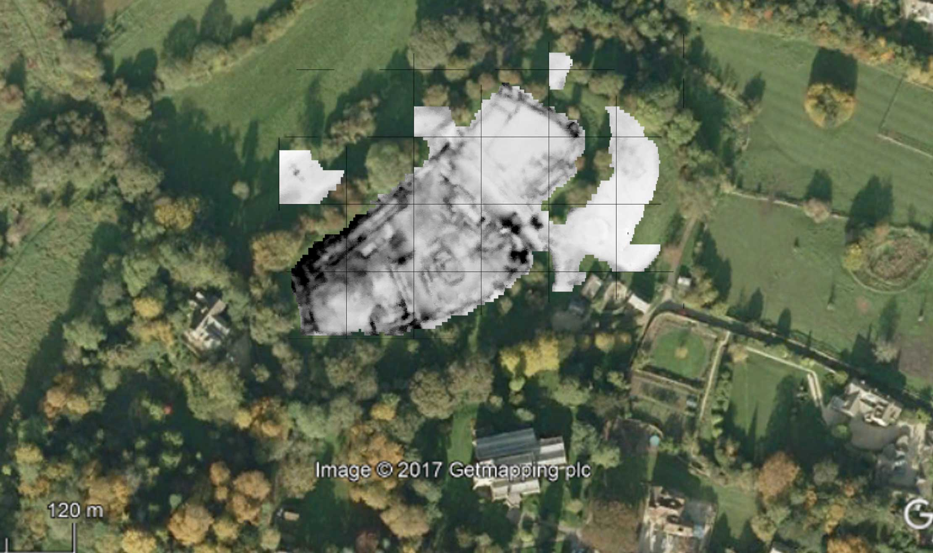

Fig1 The earth resistance survey approximately located on a Google Earth air photo

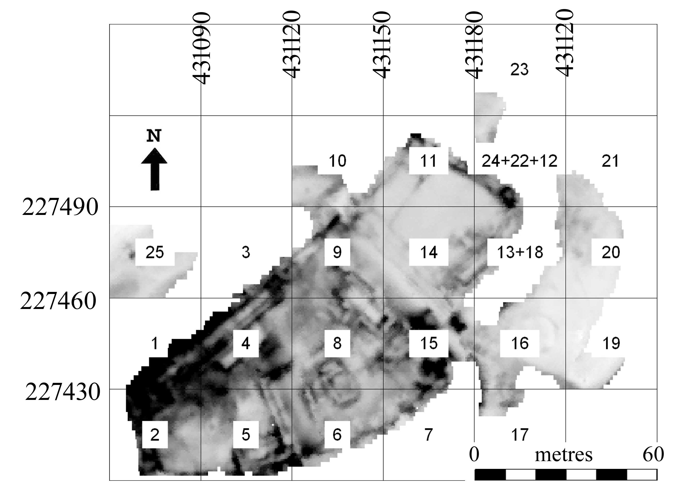
Figure 2 Detailed grid order and location
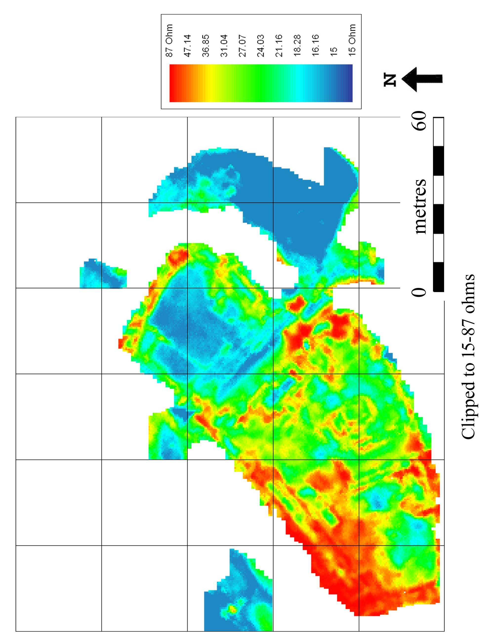
Fig 3
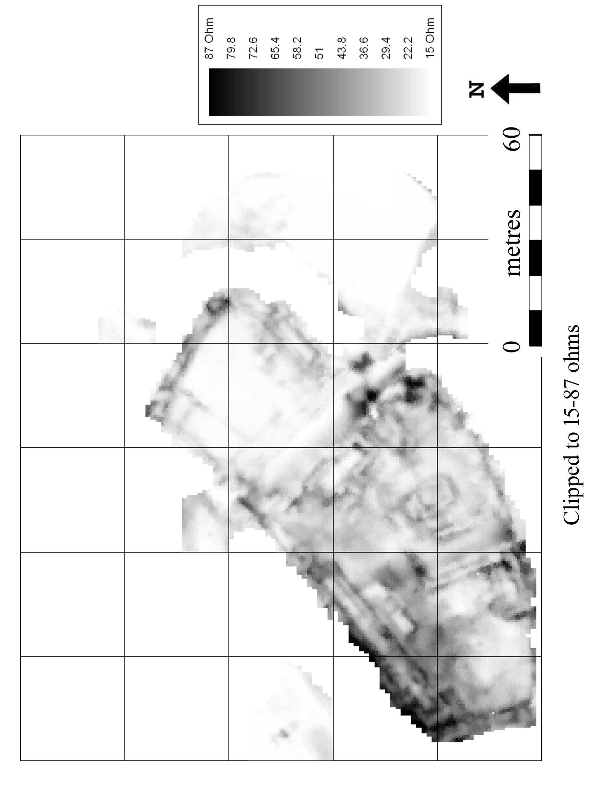
Fig 4

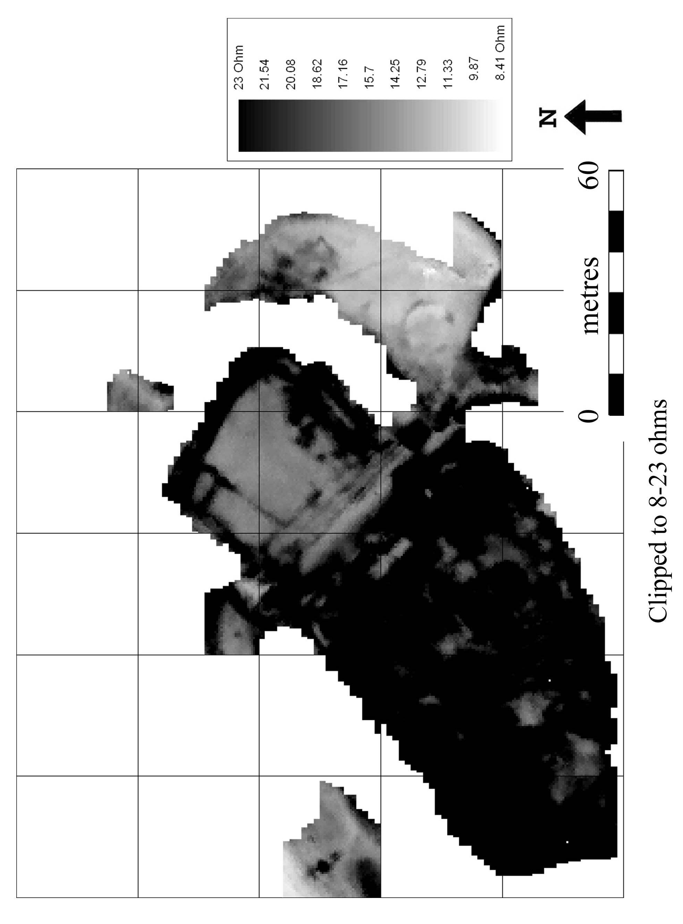
Fig 5

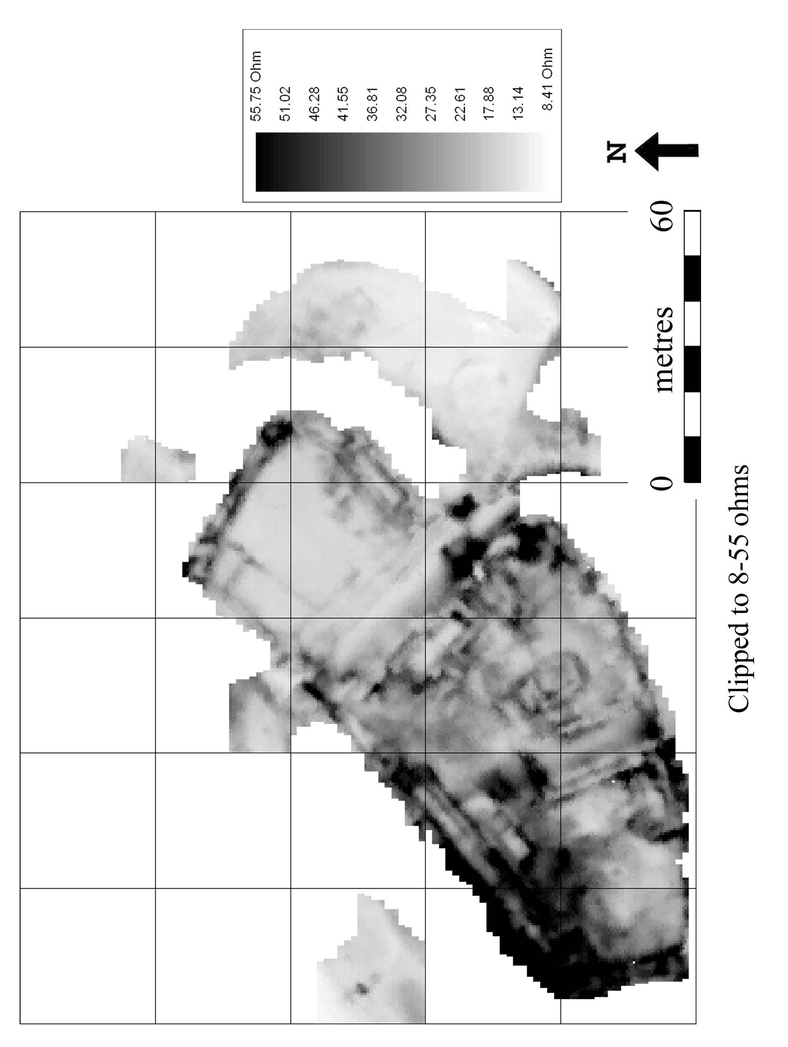

Fig 6

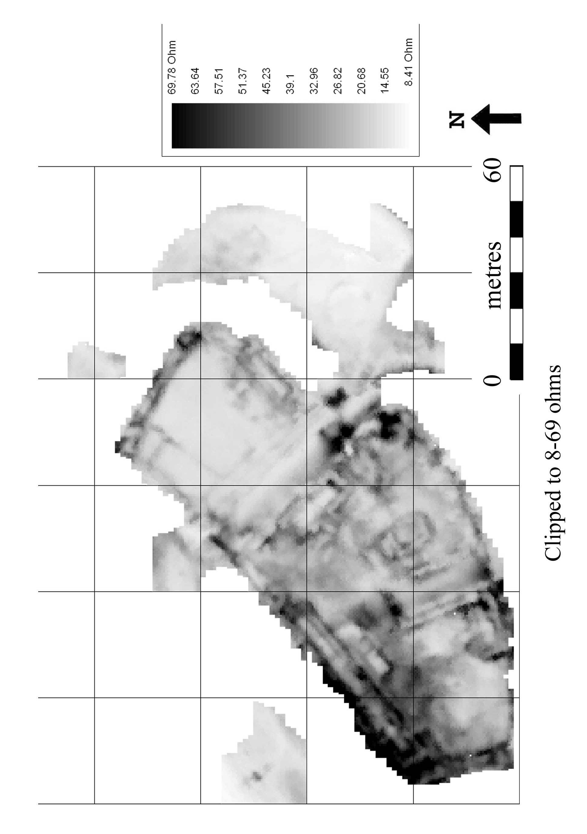
Fig 7

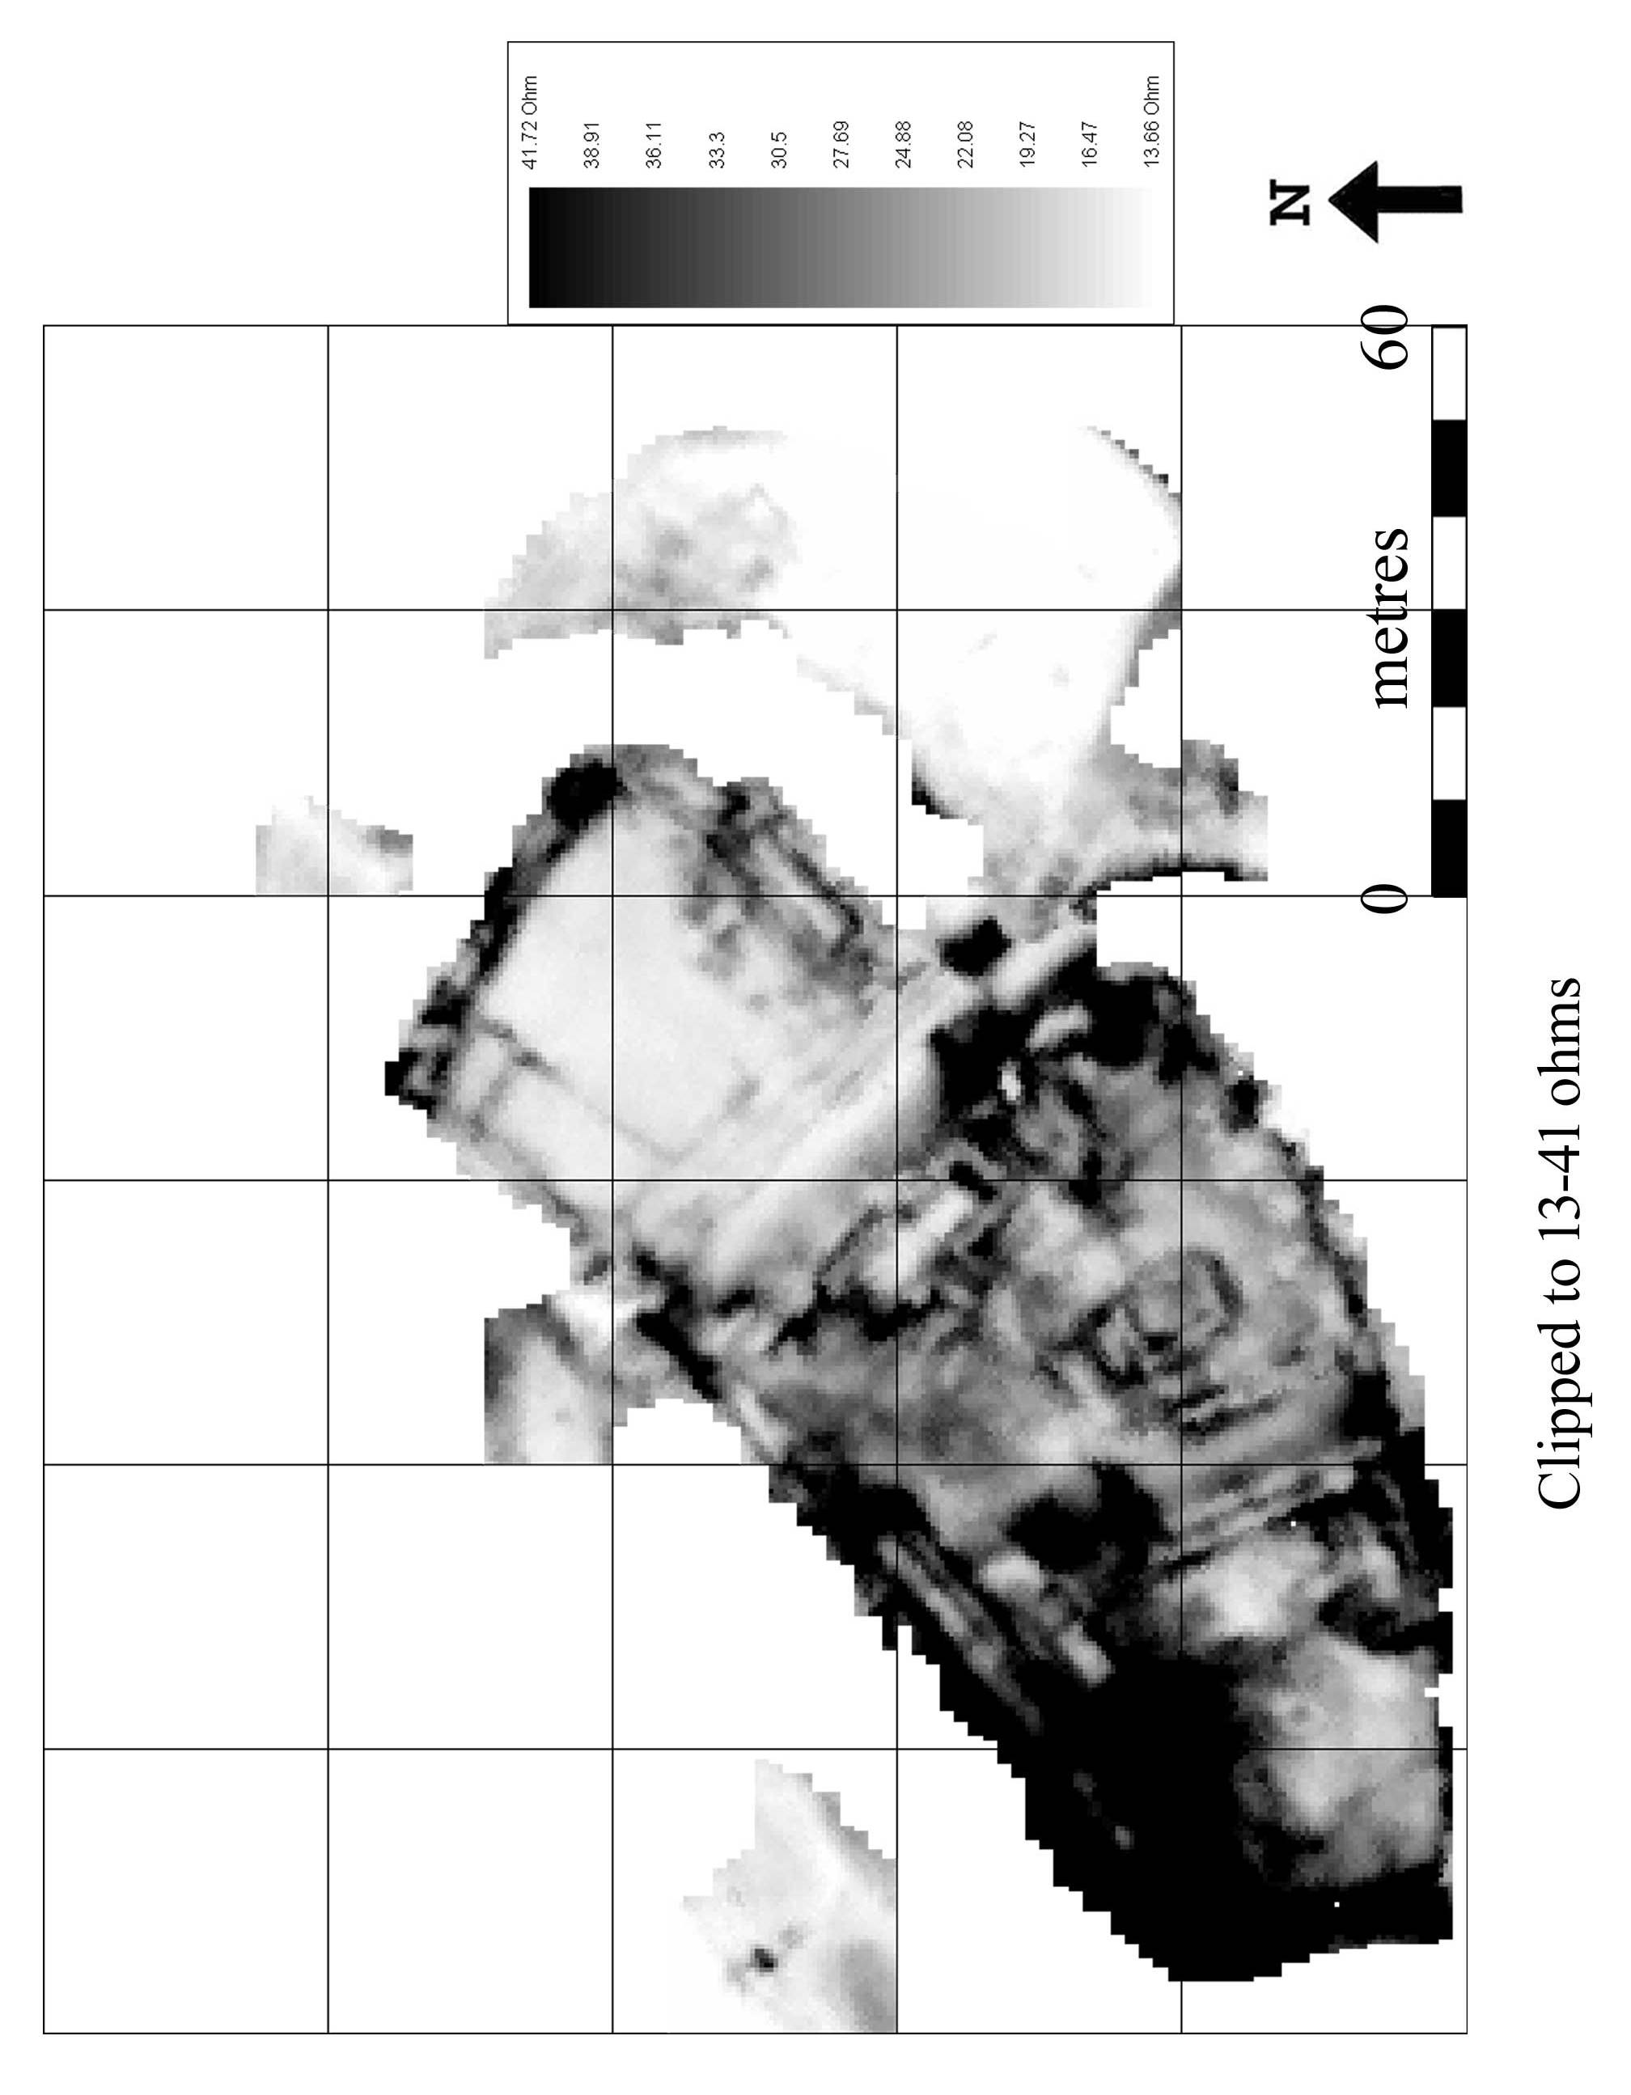

Fig 8

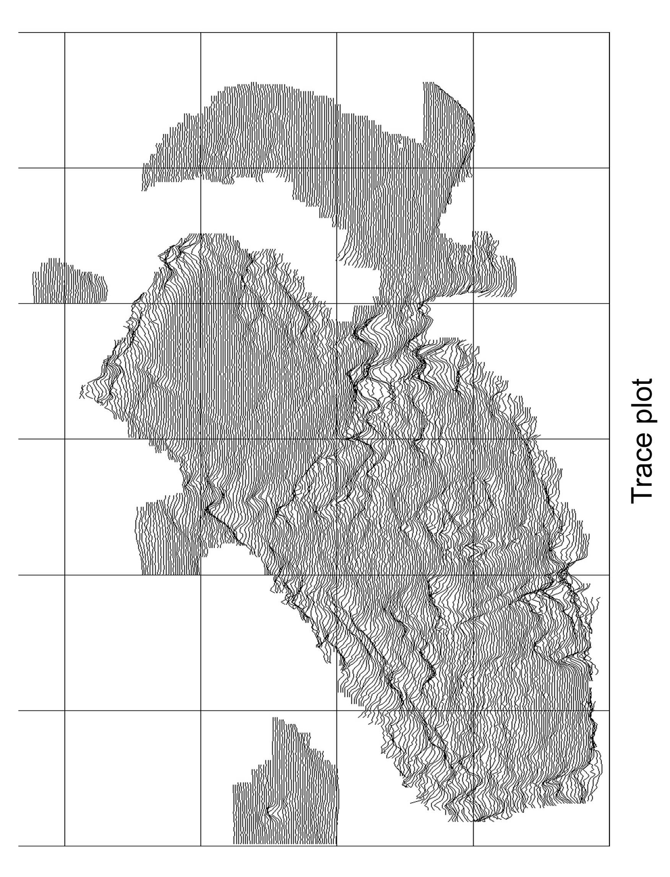
Fig 9

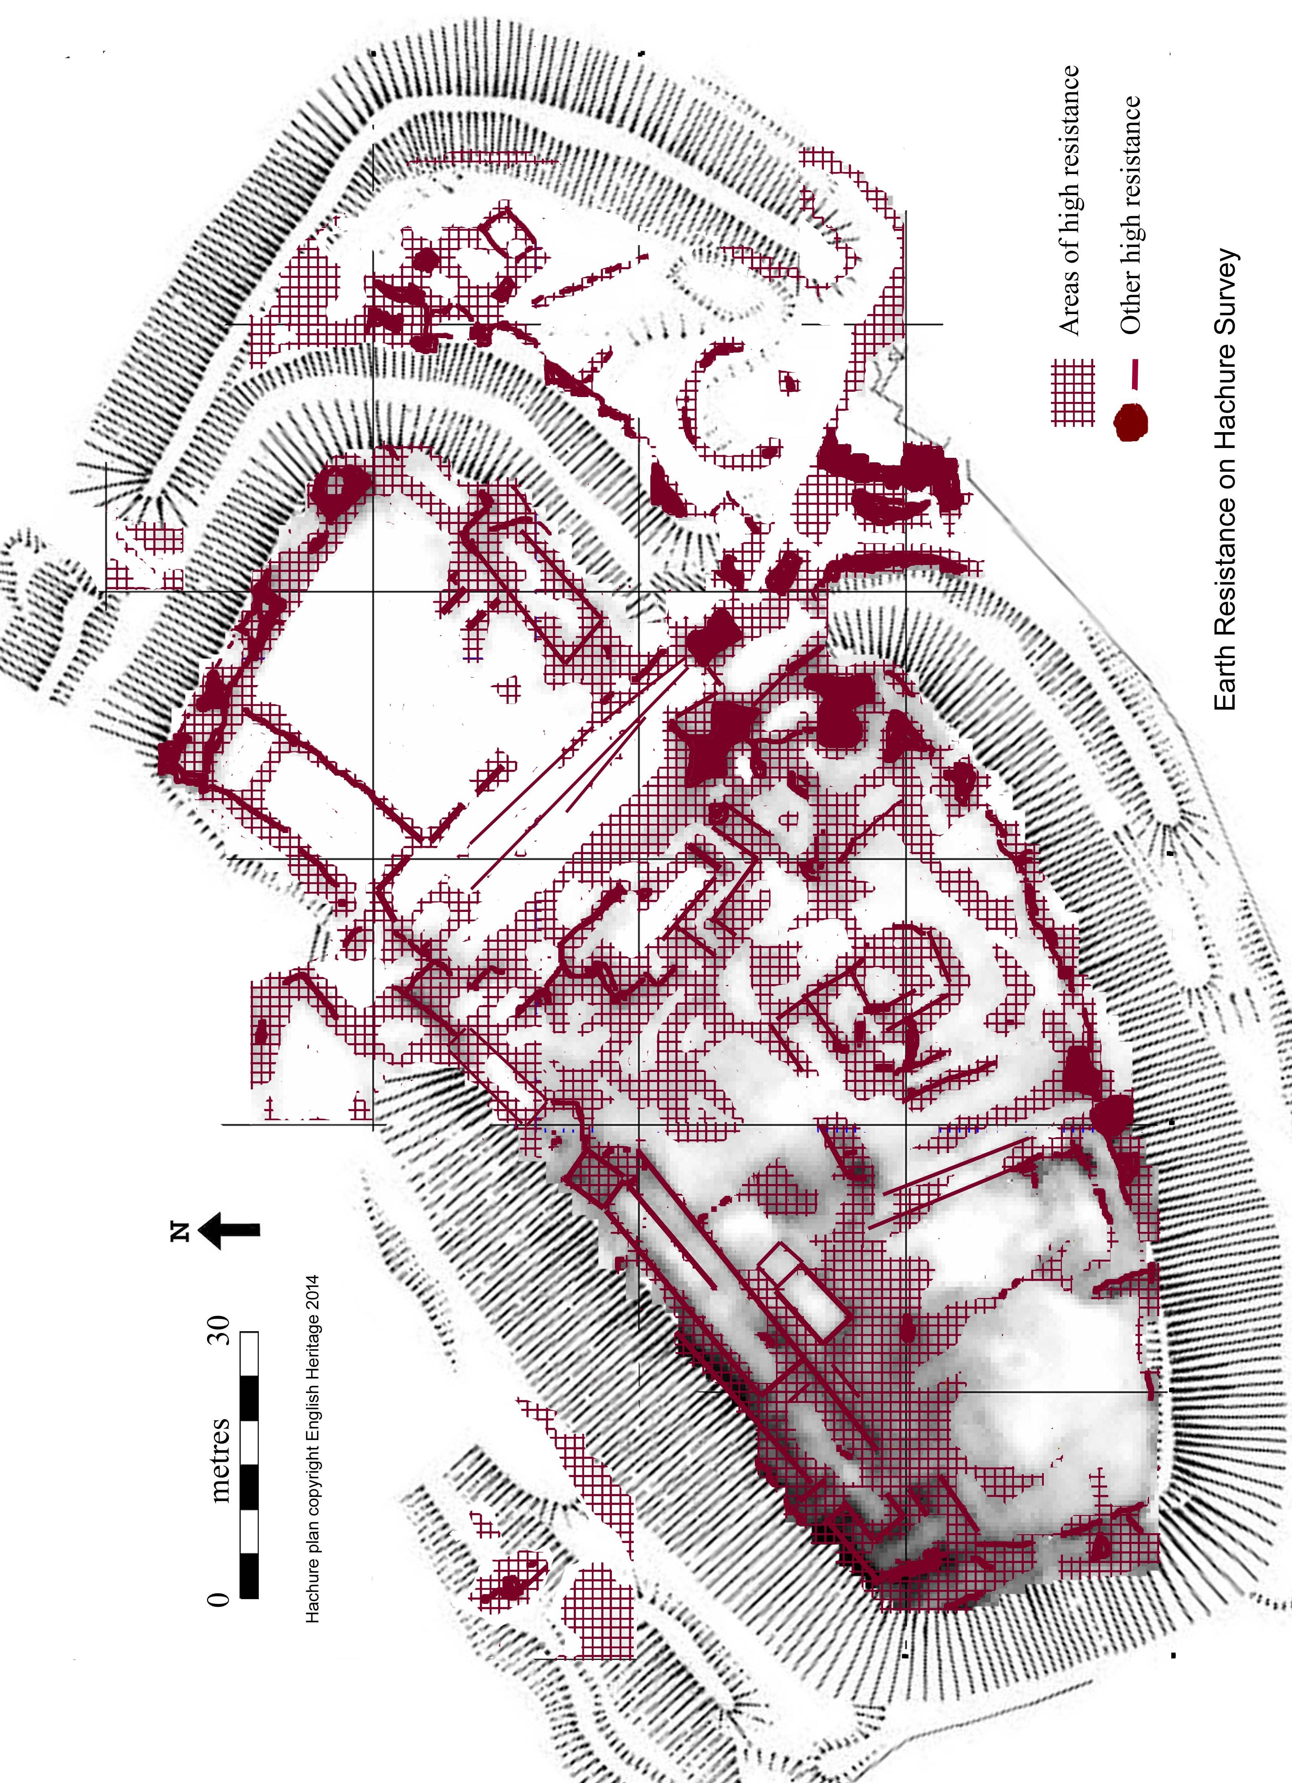

Fig 10

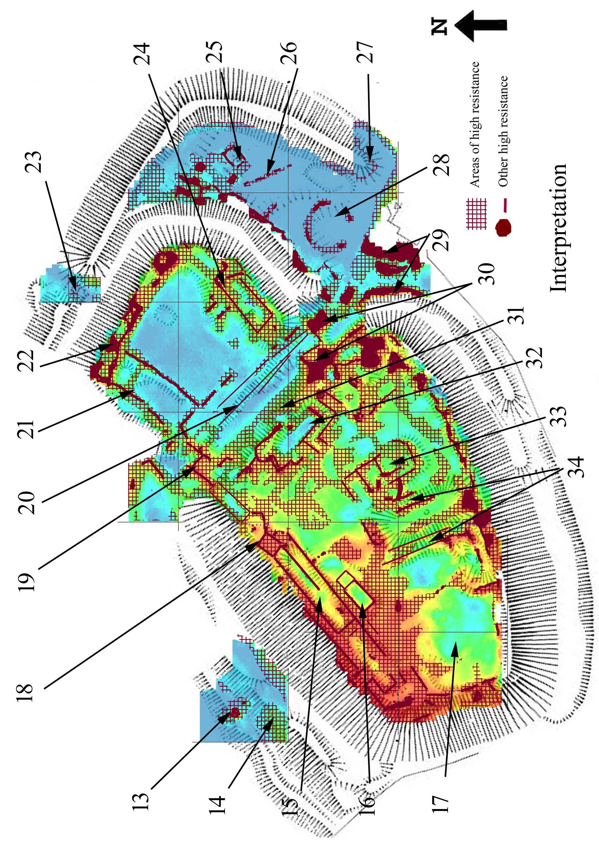

Fig 11

5 Technical details of methods and equipment.

Earth Resistance (also known as Resistivity)

This is, in theory, the simplest method as it relies on detecting the electrical resistance of the soil. In practice this is more complex as it has been found that if you just place two probes into the ground then the current between them will change as the ground around the terminals becomes polarised. Then if you then stick the probes into the same area again you get a different reading. This is caused by the contact between the soil and the probes changing each time as different surface areas of grains touch the surface of the probes. To overcome this various arrays of probes have been developed but these rely on the current being sent via one set of probes and read by another set. There are various arrays such as Wenner, Schlumberger, pole-pole and Twin. The most commonly used are twin and pole-pole, both of which involve having a pair of remote probes at least 15 metres away from the area being surveyed (assuming 0.5 metres between the mobile probes in the survey area). For a twin array the remote probes are spaced approx 0.5metres apart and this is increased to over 15 metres for pole-pole.

Earth resistance is largely dependent upon the moisture content of the soil and this will vary from day to day, producing different results. A ditch will often have silts which retain moisture whilst the natural soil around may be more freely draining. Of course the opposite can happen, as rubble filled ditches can be more freely drained than the surrounding soils. Similarly walls tend to be drier and give higher resistance values than the soil around them. Various pieces of equipment are used which can give between one and four readings at a time. Usually these have probes which are separated by 0.5 metres which can give a depth of reading of almost 1 metre-depending upon soil conditions and probe array. A 1 metre separation between the probes in the survey area, (the mobile probes), can go even deeper.

Earth resistance survey is good for finding walls but has the drawback of being far slower than magnetometry - about one third of the speed at best. The data often needs less processing than magnetometry data although high pass filtering can be useful to remove the effects of geology on a site, and de-spike used to remove the effect of the occasional poor reading caused by the probes hitting stones on the soil surface. The other main drawback of this method is that as it is greatly influenced by the amount of moisture in the soil. In the summer soil conditions can be too dry to get good results and in the winter the opposite can be the case. Often, however, something shows at most times of the year, it is just that at optimum times the clarity of the features is far better. In some areas, particularly urban areas, there are electrical currents which have leaked into the earth or are there as part of the electricity transmission system. These can badly affect the readings and filtering them out lengthens the time taken to carry out the survey.

Interpreting resistivity results can have its problems which include:-
Walls usually have high resistance but robbed out walls can have low resistance.
Ditches usually have low resistance but if they are filled with rubble or gravel they can have high resistance during dry periods.
Paved surfaces can resemble broad walls but sometimes the paving ponds groundwater creating a low resistance area.

Processing

Resistivity
This generally needs less processing than magnetometry. Clipping and replacing individual readings can stop occasional high readings caused by poor contact from distorting the survey plot. De-spike can also achieve this. Edge matching can reduce distortions caused when grids have been surveyed on different days with different amounts of soil moisture although this is usually done by adjusting the spacing of the remote probes as the survey progresses. A high pass filter can partially remove the effect of ground moisture naturally varying in a sloping field.

General Sources

CLARK A, 1996. Seeing Beneath the Soil, Routledge: London

DAVID A, 2008. Geophysical Survey in Archaeological Field Evaluation, English Heritage.

CHARTERED INSTITUTE FOR ARCHAEOLOGISTS 2014. Standard and Guidance for archaeological geophysical survey, CIfA: Reading.

EAC 2015. Guidelines for the Use of Geophysics in Archaeology: Questions and points to consider, EAC: Namur, Belgium.

GAFFNEY C and GATER J, 2003. Revealing the Buried Past, Tempus: Stroud.

SCHMIDT A 2013. Geophysical Data in Archaeology; A guide to Good Practice, Oxbow:Oxford

SCHMIDT A and MARSHALL A, 1997. Impact of resolution on the interpretation of archaeological prospection data, in Sinclair A, Slater E, and Gowlett J, Archaeological Sciences 1995, Oxbow: Oxford.

T.R SYSTEMS LTD 2017. TR/CIA Resistance meter Instruction manual, TR Systems Ltd; Peterborough

